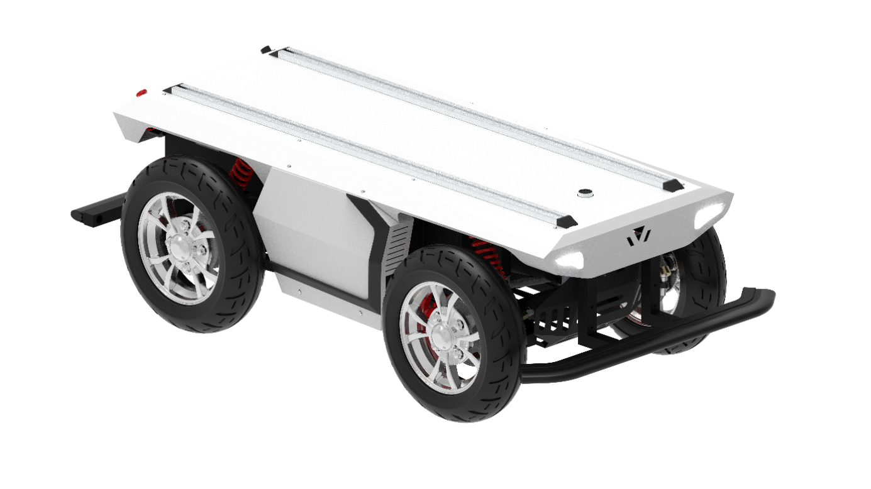****

**FR-09 Pro Ackermann Steering Drive-by-wire Chassis**

**User manual V2.2.0**

**Shenzhen Yuhesen Technology Co., Ltd.**

**CONTENTS**

1. Foreword 1

Safety information 2

2. Introduction 4

2.1. Product list 4

2.2. Performance parameters 5

3. Product presentation 7

3.1. State indicator 8

3.2. Instructions of electrical interface 9

3.3. Instructions of FS-i6S remote control 11

4. Getting started 15

4.1. Use and operation 15

4.2. Charge 15

4.3. Development 17

5. Attention 36

5.1. Attentions for battery 36

5.2. Attentions for charging 36

5.3. Attentions for usage environment 37

5.4. Attentions for remote operation 37

5.5. Attentions for external electrical extension 37

5.6. Other attentions 37

6. Common Q&A 39

7. Specifications 40

# 1. Foreword

(1) Thank you for purchasing our product, this user manual is applicable to FR-09 Pro Ackerman Drive-by-wire Chassis (hereby referred to as "FR-09 Pro").

(2) Before use, please carefully read this user manual and attentions, and correctly use strictly in accordance with this manual.

(3) For the loses caused by serious violation of this user manual, we undertake no responsibilities.

(4) Please well keep this manual for user reference during your operation.

(5) Professionals are required for commissioning, connection and installation of the chassis equipment to avoid irretrievable loses.

(6) DO NOT install, remove or replace equipment lines with electricity. If it is necessary to commission this product with electricity, please select the special commissioning tools with good insulation.

(7) Please use this product under the conditions allowed by laws and regulations, so that the public property or life safety will not be affected.

(8) We will irregularly update this product, the contents of update will be added into the new manual without notification.

(9) This manual may contain the contents which are not correct in technology or which do not comply with the operation. In case of problems which cannot be solved during use of this manual, please contact with the customer service or technical department of us.

(10) As for the contents of this manual, we will try our best to ensure that they are correct and accurate. In case of any improper or incorrect contents, please contact us for confirmation, thank you!

# Safety Information

The information herein does not include how to design, install or operate a complete robot, nor the peripheral equipment which may affect the safety of this complete system. The design and use of the complete system comply with the safety requirements formulated in the national standards and specifications. The integrators and end customers of FR-09 Pro are responsible for being sure to comply with practical laws and regulations of relevant countries to ensure that the application of the complete robot will not cause any major danger. These include but are not limited to the following:

* **Effectiveness and responsibilities:**
* A risk evaluation shall be conducted to the complete robot system. All the additional safety equipment of other machineries defined by risk evaluation shall be connected. It shall be ensured that, the design and installation of the peripheral equipment of the whole robot system, including software and hardware system, are correct.
* This robot is not equipped with relevant safety functions that a complete autonomously moveable robot shall have, including but not limited to automatic collision avoidance, fall prevention and alarm for creature approaching, etc. For relevant functions, the integrators and end customers are required to conduct safety evaluation in accordance with relevant regulations and feasible laws and regulations to ensure that the developed robot has no any major danger or potential safety hazard during actual application.
* Collecting all the documents of technical files: Including risk evaluation and this manual. Before operation and use of equipment, the existing safety risks may be known.
* **Environments:**
* For first use, please carefully read this manual to understand the basic contents and operation specifications.
* For remote operation, please select the areas which are relevantly open. This chassis is not equipped with any sensor for automatic obstacle avoidance.
* This chassis shall be used under the temperature of -20°C~60°C.
* The chassis is not customized for IP protection grade, the IP protection grade of this chassis is IP44.
* **Inspection:**
* Inspecting to ensure that the batteries of the equipment are full.
* Ensuring that the chassis has no abnormality.
* Inspecting whether the battery of the remote controller is full.
* **Operation:**
* In case of Commissioning with remote control, please make sure the remote control is on. And ensure that the vehicle can receive remote control commands.
* Ensuring that operation is conducted in a relatively open place. And remote control shall be conducted with sight distance.
* FR-09 Pro The maximum load is 300KG, during use, it shall be ensured that the effective load does not exceed 300KG.
* In case of alarm of low battery of the equipment, please charge timely. In case of equipment abnormality, please stop use immediately to avoid secondary damage.
* In case of equipment abnormality, please contact relevant technicians, DO NOT process without permission.
* Please use the equipment in the environment which meets the IP protection grade requirements of the equipment.
* During charging, please ensure that the environment temperature is higher than 0°C.
* **Maintenance:**
* In case of serious tire wearing, please replace timely.
* If the battery will not be used for a long time, when the battery is fully charged, please charge the battery regularly in each month.
* The battery shall be used once a month at least.

# 2. Introduction

FR-09 Pro is a versatile drive-by-wire robotics mobile platform, it adopts Ackerman front steering, and rear drive form. Compared with the chassis of differential drive form on the ordinary pavement, FR-09 Pro has a faster traveling ability and relatively strong load capacity. At the same time, the wearing of tire is lighter, matching with whole bridge suspension, the chassis can pass through the common obstacles, such as speed bump, etc. Therefore, it is more applicable for long-term outdoor traveling; And this chassis is a underlayer control system structure based on VCU vehicles control, it uses CAN bus management, having the features of high precision and modularization, etc. By the modules and navigation systems of LiDAR, GPS and manipulator, etc., this chassis is widely used in autonomous driving, unmanned patrol, logistics, transportation distribution, scientific research and various new applications and explorations requiring for mobile chassis.

## 2.1. Product list

After delivery, please carefully confirm the product list:

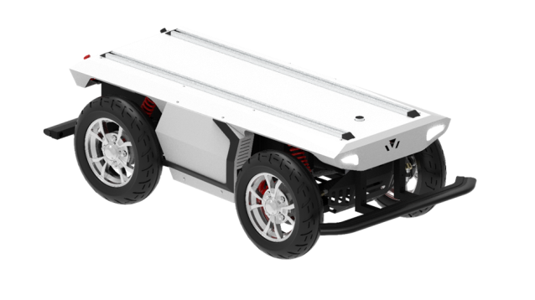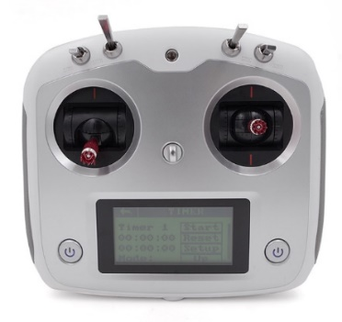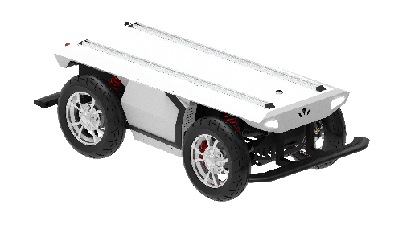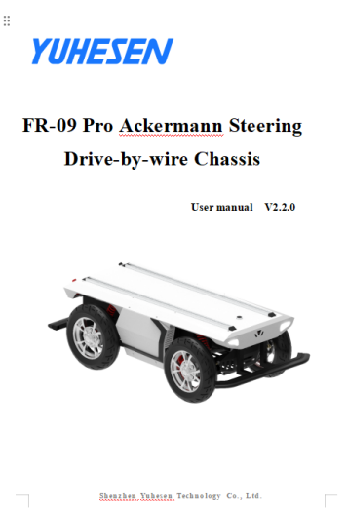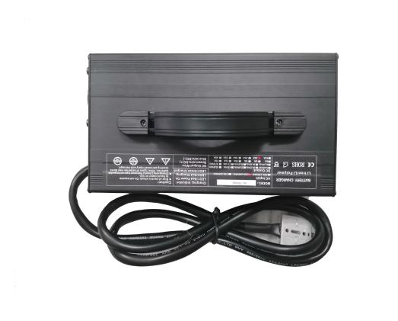

Charger (48V) *1

Chassis *1

Product manual *1

Remote controller *1

## 2.2. Performance parameters

Table 2 - 1 FR-09 Pro Performance Parameter Table

|  |  |  |
| --- | --- | --- |
| **Parameter type** | **Performance** | **Parameter** |
| Structural size and weight | Dimensions(W*D*L) | 1,600*820*520mm |
| Weight | 176kg |
| Drive | Ackermann front steering and rear wheel drive |
| Suspension | Whole bridge suspension |
| Material | Q235 |
| Ground clearance | 110mm |
| Wheelbase | 850mm |
| Wheel track | 645mm |
| Tire type/diameter | 120/70-10, 420mm |
| Basic configuration | Driving motor | 1,800W, DC brushless motor |
| Steering motor | 400W, servo motor |
| Battery type | 48V/70AH lithium battery/BMS management system |
| Charging time | ≤4h |
| Charging method | 48V/20A, manual charging by charger |
| External power supply | 48V/20A-24V/15A-12V/15A |
| Braking mode | Hydraulic disc brake + motor brake |
| Parking method | Solenoid brake |
| Turn signal light | √ |
| Horn | √ |
| Brake lamp/deceleration indicator/fault indicator | √ |
| Wheel speed sensor | √ |
| Safety measures | Emergency stop button | √ |
| Front and rear bumper strip | √ |
| Command check | √ |
| Heartbeat protection | √ |
| Fault handling for steering system | √ |
| Fault handling for braking system | √ |
| Fault handling for driving system | √ |
| Emergency power down parking protection | √ |
| Battery fault monitoring and protection | √ |
| Online detection for whole vehicle CAN node | √ |
| Whole vehicle fault level division and processing | √ |
| Vehicle fault warning | √ |
| Prompt of fast vehicle deceleration | √ |
| Processing of remote controller disconnection | √ |
| Charging safety monitoring and protection | √ |
| VCU configuration | Dominant frequency | 168MHz |
| flash | 512KB |
| Hardware floating point acceleration | √ |
| Movement control | √ |
| Communication interface | CAN interface |
| Communication protocol | CAN 2.0B |
| Performance parameters | Remote control distance | 100m |
| Vertical load (level road) | 300kg |
| Speed | 18km/h |
| Mileage | 70km (no load) |
| Minimum turning radius | 2.4m |
| Wading depth | 100mm |
| Maximum climbing angle | 10° (full load) |
| Crossing width | 200mm (full load) |
| Obstacle surmounting height | 60mm (full load) |
| Performance parameters | Steering accuracy | ≤0.5° |
| Protection level | IP44 |
| Operating temperature | -20°C~60°C |
| Storage temperature | 0°C~40°C |

# 3. Product presentation

The contents in this part are only the basic introductions for FR-09 Pro Ackerman Drive-by-wire Chassis, facilitating the users and developers to know FR-09 Pro chassis basically. As shown in Figure 3-1 and Figure 3-2, there are the front and rear overall figure of the whole Ackerman drive-by-wire chassis.

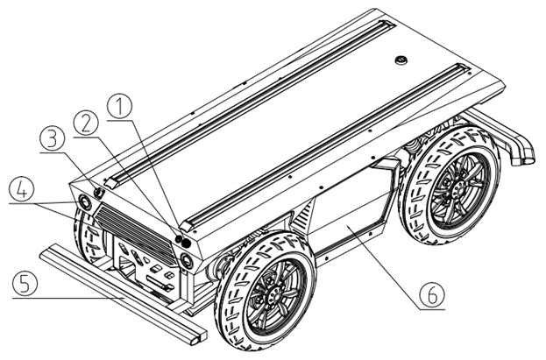

Figure 3 - 1 Tail Overall Figure

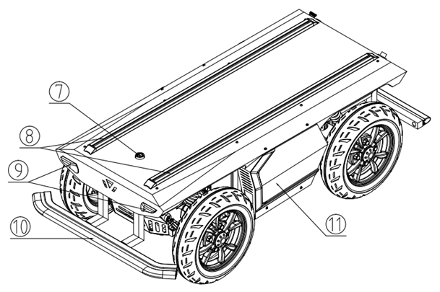

Figure 3 - 2 Front Overall Figure

Note: ①Emergency stop button；②Power button；③Charging interface；④Rear lamp；⑤Rear strip bumper ；⑥Right battery compartment panel；⑦Top electrical interface；⑧Aluminum extrusion rail；⑨Position lamp and front steering lamp；⑩Front strip bumper；⑪Left battery compartment panel

Overall, FR-09 Pro uses the thought of modular design, resulting in high safety and reliability. In structure, front Ackerman steering structure, rear whole bridge suspension and non-bearing vehicle body design make high vehicle body strength and high rigidity, so that the safety of the whole vehicle can be improved, bringing relatively strong impact resistance and performance of resistance to bump, so that the trafficability characteristics are excellent, and the vehicle can pass the pavement environments which are relatively complex.

The braking system adopts the design of motor + hydraulic disc brake, achieving safer and more effective braking. At the same time, emergency stop switch is installed at the tail of the vehicle body. In case emergency, the traveling of the vehicle can be stopped by beating, so as to control the whole vehicle. At the same time, the emergency stop switch supports functional inspection. If the emergency stop switch is damaged or in case of disconnection, VCU will control the vehicle driver to power off; Multi-protection, guaranteeing safe driving of vehicles.

The chassis is also equipped with integrated control. VCU analyzes and judges the vehicle signals uniformly, and forms closed-loop control, therefore, the faults can be diagnosed, and corresponding safety protection and processing can be conducted to reliably achieve unmanned vehicle status monitoring remotely. At the top of the vehicle body, there are electrical interfaces and communication interfaces of 48V, 24V and 12V. At the same time, the top is equipped with standard profile fixing support, so that the users can conduct secondary development quickly.

## 3.1. State indicator

Via voltage display on the remote controller and the starting sound, users can determine the status of the vehicle body. Refer to Figure 3-1 for details.

Table 3 - 1 Description of Vehicle Body Status

|  |  |
| --- | --- |
| **Status** | **Description** |
| Battery voltage | The current battery voltage of the vehicle body can be checked by sliding left the displayed on the remote controller (Figure 3-3). the percentage of the remaining battery can be known by checking Table 3-2 |
| Fault indicator | The fault status of the of the whole vehicle can be determined in accordance with the flashing frequency of the brake lamp under non-braking status and braking status. Once 1S: level I fault alarm; Twice 1S: level II fault alarm; Three time 1S: level III fault alarm |

Note:

Fault level division and processing method:

Level 1 fault: CAN signal and indicator alarm;

Level 2 fault: CAN signal and indicator alarm, and the power of the whole vehicle drops;

Level 3 fault: CAN signal and indicator alarm, the driver powers off.

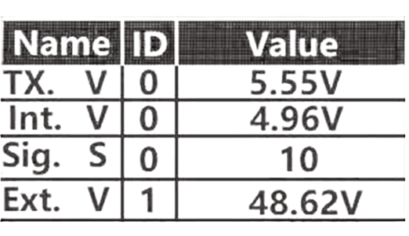

Remote controller displays the voltage

Figure 3-3 Interface of Vehicle Voltage on the Remote Controller

Note: The current interface appears by sliding the remote control screen left; Wherein, TX.V is the current battery voltage of the remote control; Int.V is the receiver power supply voltage; Sig.S is the receiver signal strength; Ext.V is the vehicle battery voltage; ID 0 is the transmitter or receiver signal of the remote control; ID 1 is the first sensor connected to the receiver and so on.

|  |  |  |  |  |  |  |  |  |  |  |
| --- | --- | --- | --- | --- | --- | --- | --- | --- | --- | --- |
| Comparison table for vehicle battery voltage and remaining percentage | | | | | | | | | | |
| Voltage (V) | 51.03 | 49.8 | 49.75 | 49.74 | 49.68 | 49.63 | 49.52 | 49.29 | 49.17 | 48.97 |
| SOC (%) | 100 | 95 | 90 | 85 | 80 | 75 | 70 | 65 | 60 | 55 |
| Voltage (V) | 48.96 | 48.95 | 48.91 | 48.82 | 48.65 | 48.45 | 48.19 | 47.83 | 47.53 | 42.65 |
| SOC (%) | 50 | 45 | 40 | 35 | 30 | 25 | 20 | 15 | 10 | 7 (Stop output) |

Table 3-2 Comparison Table for Vehicle Battery Voltage and SOC

## 3.2. Instructions of electrical interface

### **3.2.1.** Instructions of top electrical interface

FR-09 Pro is equipped with a WS32-11 electrical interface on the top. This electrical interface is set with three sets of different power supplies and a set of CAN communication interface, and the wires have been led out, so that, the users can provide power supplies and communication to different extension equipment. Refer to the schematic diagram of the top electrical position in Figure 3-4 for details

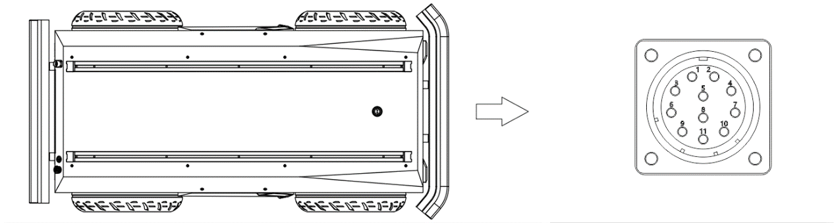

Figure 3 -4 Schematic Diagram of Top Electrical Position

The specific pin definitions of top electrical interfaces are shown in Table 3-3 below

|  |  |  |  |
| --- | --- | --- | --- |
| Pin | Type | Definition | Remark |
| 1 | reserve | reserve | reserve |
| 2 | Power supply | 48V- | Negative pole of 48V power supply |
| 3 | 48V+ | Positive pole of 48V/10A power supply |
| 4 | 24V- | Negative pole of 24V power supply |
| 5 | reserve | CAN2_L | CAN2 bus - low |
| 6 | Power supply | 24V+ | Positive pole of 24V/15A power supply |
| 7 | 12V- | Negative pole of 12V power supply |
| 8 | reserve | CAN2_H | CAN2 bus - high |
| 9 | Power supply | 12V+ | Positive pole of 12V/15A power supply |
| 10 | CAN | CAN_L | CAN bus - low |
| 11 | CAN_H | CAN bus - high |

### Table 3 -3 Pin Definitions of Top Electrical Interface

It shall be noted that, the power supply for expansion is controlled internally. When the battery voltage is under-voltage, BMS will protect, and the battery stops discharging. During use, users are required to charge.

### **3.2.2.** Instructions of electrical panel at the tail

The electrical panel at the tail is shown as Figure 3-5. Wherein, B1 is emergency stop switch; B2 is starting switch; B3 is the interface for charging .

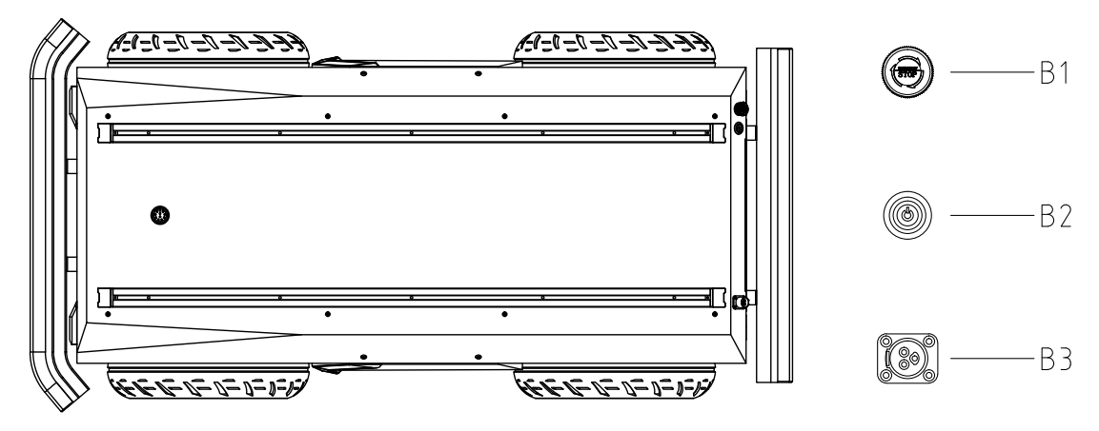

Figure 3 -5 Tail View and Electrical Panel

## 3.3. FS-i6S Remote control instructions

The remote controllers have been paired before delivery, there is no need to modify the setups. Modification of remote controller setups without permission may lead to the problems of chaos in control and being out of control, etc. DO NOT modify the remote controller setups at will; In case of parameter faults, please contact our customer service or technical support. In case of modification, professional technicians are required for setting of remote controller.

### **3.3.1. Instructions of FS-i6S remote control**

Each FR-09 Pro is equipped with a FS-i6S remote controller. With this remote controller, users can easily control FR-09 Pro. For FS-i6S remote controller of this product, we use the design of brake by the left hand, forward-backward acceleration, left-right rotation by the right hand. Refer to Figure 3-6 for the definitions and functions

Mobile bracket interface

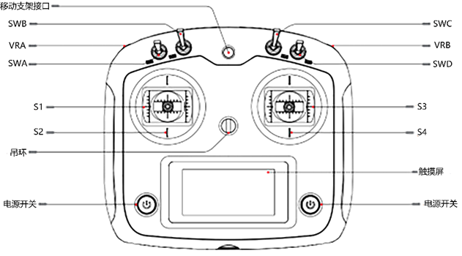

Touch screen

Power button

Suspension ring

Power button

Figure 3 -6 Schematic Diagram of operation panel of FS-i6S remote controller

The parameters of the remote controller have been configured before delivery. DO NOT modify the system configuration of the remote controller without permission, or, the robot may be out of control and in controlling chaos, etc. In case of any question, please contact the customer services or after-sales personnel for answering;

(1) SWA is the driving lever to switch the control mode. There are two control modes. For example, when the observe side of the remote controller is upward, and the driving lever of the SWA driving lever is upward, the control mode is remote controller control mode; when the SWA driving lever is downward, the control mode is command control mode;

(2) SWB is the driving lever to switch the gear. There are three gears. When the driving lever is in the center, and the vehicle is under N gear, forward-backward movement control signals will not be received; When the driving lever is pulled upwards to switch to Gear D, can the chassis receive the front movement signal transmitted by S2 rocker and move forwards; When the driving lever is pulled downwards to switch to Gear R, can the chassis receive the reverse movement signal transmitted by S4 rocker and move backwards;

(3) VRA is the driving knob of horn control, it will return automatically. When this driving knob is pulled downwards for one time, the horn will sound for one time;

(4) VRB is the driving knob for parking request. When the driving knob is pulled upwards, parking request will be transmitted, and the park braking system starts; When the driving knob is pulled downwards, parking release request is transmitted, and the park braking system releases.

(5) S2 is braking rocker, upward pushing for braking, and downward pushing to the bottom for braking release. The openness of the braker is determined in accordance with the position of S2 rocker. When S2 is pushed to the top, the braking force reaches the maximum value, and when it is pushed to the bottom, the braker is released;

(6) S4 is the accelerator control rocker, controlling the forward movement speed and backward movement speed of FR-09Pro; Left and right movement of S3 control the steering of the front wheels;

(7)   SWC is the high, medium and low speed controller of S4 rocker. For example, S4 rocker controls the vehicle to run in low speed mode when SWC is in the top position; S4 rocker controls the vehicle to run in medium speed mode when SWC is in the middle position; S4 rocker controls the vehicle to run in high speed mode when SWC is in the lowest position;

(8) The power button is the power control switch of the remote controller. When the remote controller is in the shutdown state., press and hold the power buttons on both sides of the monitor to turn it start; When the remote controller is in the boot state., press and hold the power buttons on both sides of the monitor to turn it off. If the receiver of the remote controller is powered on and the power buttons on both sides of the monitor cannot be turned off, the battery needs to be unloaded to turn it off.

### **3.3.2.** Instructions of remote controller buzzer alarm

|  |  |
| --- | --- |
| Position switch alarm | During startup, if the driving levers of switch SWA/SWB/SWC/SWD are not in the default gears, alarm interface will appear, prompting to turn all switches up. And all switches will normally enter the main interface when they are in the default gear |
| Low-voltage alarm | When the voltage is lower than the alarm voltage, the system will give an alarm, and the display of the remote controller will start flashing. If the remote control voltage is too low, the TX icon flashes, and if the chassis voltage is too low, the RX icon flashes |
| Unusual communication alarm | When the control distance between the remote controller and the chassis is too far or the environment is blocked, the intensity of the remote control signal will be reduced. If the signal intensity is lower than 5, an unusual communication alarm will give an alarm to remind the user that the remote control signal intensity is weak |
| Remote control does not use alarm | When the remote controller is not used for a long time, the buzzer of the remote controller gives an intermittent alarm. |
| Shutdown alarm | When the remote controller is turned off, it will detect whether the chassis is turned off. If the chassis is not turned off, a warning interface will pop up, and it is necessary to turn off the chassis power before turning off the remote controller. (If you need to turn off the remote controller forcibly when the chassis is not turned off, you can remove the battery. ) |

Table 3 -4 Instructions of Remote Controller Alarm Condition

### **3.3.3.** Instructions of control commands and movement

In accordance with ISO 8855, we establish coordinate system as shown in Figure 3-7 for ground movement of the vehicle.

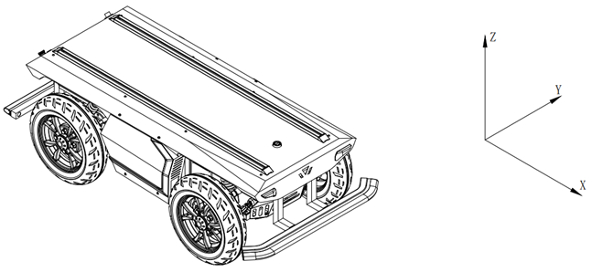

Figure 3 -7 The Vehicle Coordinate System

As shown in Figure 3-7, the vehicle body of FR-09 Pro is parallel to axis-X of the established coordinate system.

Under remote controller control mode, pull down the VRB knob to release the parking gear, switch the SWB lever to D gear, push the S4 rocker forward to move in the positive direction of X, switch the SWB lever to R gear, and push the S4 rocker backward to move in the negative direction of X; When the S4 rocker is pushed forward to the maximum value, it moves in the X direction to control the high, medium and low speed according to the high, medium and low speed set by SWC. When S4 rocker is pushed backwards to the maximum value, it moves in the negative direction of X, and the high, medium and low speed are controlled according to the high, medium and low speed set by SWC. Left and right movement of remote controller rocker S3 control the steering of the front wheels. When S3 is pushed leftwards, the vehicle turns left, and when it is pushed to the maximum value, at this time, the speed of turning left is the maximum; when S3 is pushed rightwards, the vehicle turns right, and when it is pushed to the maximum value, at this time, the speed of turning right is the maximum.

Under the control command mode, at the target gear, the value of 04 indicates that the target gear moves along the positive direction of axis-X, and the value of 02 indicates that it moves along the negative direction of axis-X.

# 4. Getting started

This part mainly introduces the basic operation and use of FR-09 Pro platform, and how to conduct secondary development to the vehicle body through CAN bus protocol.

## 4.1. Use and operation

**The basic operations flow of remote operation are as follows:**

**Inspection**

(1) Check the status of the vehicle body. Check that whether the vehicle body has obvious abnormality; If any, please contact after-sales support;

(2) Check the status of the emergency stop button, and confirm that the emergency stop button at the tail is under the released state;

(3) Check that all gears of the remote controller are in neutral position;

**Start-up**

1. Press and hold the power buttons on both sides of the monitor to turn on the remote controller.
2. Press B2 (starting switch)

(3) Check the vehicle battery voltage of the remote controller to see that whether the battery voltage is normal. If the voltage is lower than 47.5V, please charge first.

(4) Release the brake of the vehicle, switch to remote driving mode to observe that whether the brake lamp flashes and whether the vehicle is faulty. If there is any fault, connect to the CAN card to read the vehicle fault status and signal, and then, contact the after-sales personnel for solving.

**Close operation**

Press B2 (starting switch) again and release the switch to turn off the power supply;

**Emergency stop**

Beat the emergency stop switch on the electrical panel at the tail of FR-09 Pro vehicle body;

## 4.2. Charge

The chassis of the FR-09 Pro mobile robot is equipped with a 48V/20A charger in default, meeting the demands of charging of the users.

The specific operation processes of charging are as follows:

1) Before charging, please make sure that FR-09 Pro is shut down and powered off, and confirm that B2 (starting switch) on the electrical board at the tail is closed;

2) First, insert the output plug of the charger into the B1 charging interface on the electrical board at the tail; Then, plug the AC plug of the charger into the 220V AC socket.

3) After charging, operate in accordance with the reserve orders, unplug the AC plug first, and then, unplug the output plug.

4) The working status indicator of the charger is shown in Table 4-1.

Table 4 -1 Instructions of LED Indicator for Charger Status

|  |  |
| --- | --- |
| LED indicator light status | Charger status |
| LED1 is in bright red | The input line plug of the charger has been powered on |
| LED2 is in bright red | Indicating that the charger is charging |
| LED2 is in bright green | Indicating that the battery has been fully charged |

5) If the temperature of the charging environment is too high, the charger may enable temperature protection. Please move the charger to a cool or ventilated place for use, and resume normal charging when the internal temperature of the charger is lowered to 60°C. Refer to Table 4-2 for the instructions of charger protection status:

Table 4 -2 Instruction of Charger Protection Status

|  |  |
| --- | --- |
| **Protection function** | **Function description** |
| Over-heating protection | When the internal temperature of the charger reaches the over-temperature protection point, the charger stops charging automatically. |
| Output short-circuit protection | When the charger output is short-circuited unexpectedly, the charger turns off output automatically. |
| Output reverse connection protection | When the battery is connected in reverse, the charger will cut off the connection between the internal circuit and the battery. |
| Output over-voltage protection | When the output of the charger is over-voltage, the charger automatically turns off the output. |

Note:

When the vehicle is being charged, VCU will protect the charging state of the whole vehicle. If the vehicle is being charged when it is powered on, to ensure the charging safety, the vehicle will enable hydraulic braking and electromagnetic band-type parking brake. At the same time, the driver will be controlled to power off under high voltage. After charging, the driver will recover automatically. At the same time, the CAN signal will send the corresponding charging flag bit, and when necessary, if release is required, corresponding commands can be sent for release.

## 4.3. Development

FR-09 Pro product provides CAN interface to users for development, and users can conduct command control to the vehicle body with CAN interface.

### **4.3.1.** CAN interface protocol

The communication of FR-09 Pro product is conducted by CAN2.0B extended frame, and the message format is Intel format with a baud rate of 500K. Through the external CAN bus interface, the vehicle speed, steering angle, brake pedal openness and parking request of the chassis can be controlled. The FR-09 Pro will feed back the current movement state information and the system state information of the FR-09 Pro chassis in real time.

The specific protocol contents are shown as below:

**The motion command control frame includes gear control, vehicle speed control, steering angle control, brake pedal opening, parking request and inspection, etc. The specific protocol contents are shown in Table 4-3. Refer to 4.3.2 for wiring instructions, and 4.3.3 for CAN communication transmission requirements and test examples.**

Note: The CAN interface is a non-isolated interface. During use, please prevent the CAN line from being wrongly connected or prevent the CAN bus from being connected with the power line of the given type. In case of connection, VCU may be burned out.

CAN protocol is shown as below:

Table 4-3 Command Control Frame and System Feedback Frame

|  |  |  |  |  |  |  |  |  |  |
| --- | --- | --- | --- | --- | --- | --- | --- | --- | --- |
| **Chassis control command** | | | | | | | | | |
| **Message name** | | | **ID** | | | | **Cycle**  **(ms)** | | **(Byte)**  **Message length** |
| ctrl_cmd | | | 0x18C4D2D0 | | | | 10 | | 8 |
| **Signal description** | **Arrangement format** | **Starting byte** | **Start bit** | **Signal duration** | **Data type** | **Precision** | **Offset** | **Unit** | **Signal value description** |
| Target gear | Intel | 0 | 0 | 4 | Unsigned | 1 | 0 |  | 00: disable  01: Gear P  02: Gear R  03: Gear N  04: Gear D |
| Target vehicle speed | Intel | 0 | 4 | 16 | Unsigned | 0.001 | 0 | m/s | 0.001m/s/bit; |
| Targeted vehicle steering angle | Intel | 2 | 20 | 16 | signed | 0.01 | 0 | ° | 0.01°/bit; |
| Targeted vehicle braking | Intel | 4 | 36 | 8 | Unsigned | 1 | 0 |  | 1%/bit |
| Alive Rolling Counter  Heartbeat signal (loop counter) | Intel | 6 | 52 | 4 | Unsigned | 1 | 0 |  | For each sent frame, the value will increase by 1, after the maximum value is reached, the value will be reset to 0 to check packet loss and disconnection |
| Check BCC  XOR checkout for message | Intel | 7 | 56 | 8 | Unsigned | 1 | 0 |  | Checksum = Byte0 XOR Byte1 XOR Byte2 XOR Byte3 XOR Byte4 XOR Byte5 XOR Byte6 |
| **Chassis I/O control command** | | | | | | | | | |
| **Message name** | | | **ID** | | | | **Cycle**  **(ms)** | | **(Byte)**  **Message length** |
| io_cmd | | | 0x18C4D7D0 | | | | 50 | | 8 |
| **Signal description** | **Arrangement format** | **Starting byte** | **Start bit** | **Signal duration** | **Data type** | **Precision** | **Offset** | **Unit** | **Signal value description** |
| I/O control enabling | Intel | 0 | 0 | 1 | Unsigned | 1 | 0 |  | 0 = off  1 = on |
| Steering lamp switch | Intel | 1 | 10 | 2 | Unsigned | 1 | 0 |  | 0 = Fully close  1 = left steering lamp on  2 = right steering lamp on |
| Position lamp switch | Intel | 1 | 13 | 1 | Unsigned | 1 | 0 |  | 0 = off  1 = on |
| Loudspeaker switch | Intel | 2 | 16 | 1 | Unsigned | 1 | 0 |  | 0 = off  1 = on |
| Enforced power-on flag bit for charging | Intel | 5 | 40 | 1 | Unsigned | 1 | 0 |  | When the flag bit is forced to be enabled under the charging state, the vehicle can be controlled to be powered on under 48V, and the vehicle can resume control. When the flag bit is enabled, the vehicle cannot reverse under the charging state. |
| Alive Rolling Counter  Heartbeat signal (loop counter) | Intel | 6 | 52 | 4 | Unsigned | 1 | 0 |  | For each sent frame, the value will increase by 1, after the maximum value is reached, the value will be reset to 0 to check packet loss and disconnection |
| Check BCC  XOR checkout for message | Intel | 7 | 56 | 8 | Unsigned | 1 | 0 |  | Checksum = Byte0 XOR Byte1 XOR Byte2 XOR Byte3 XOR Byte4 XOR Byte5 XOR Byte6 |
| **Chassis control feedback command** | | | | | | | | | |
| **Message name** | | | **ID** | | | | **Cycle**  **(ms)** | | **(Byte)**  **Message length** |
| ctrl_fb | | | 0x18C4D2EF | | | | 10 | | 8 |
| **Signal description** | **Arrangement format** | **Starting byte** | **Start bit** | **Signal duration** | **Data type** | **Precision** | **Offset** | **Unit** | **Signal value description** |
| Target gear | Intel | 0 | 0 | 4 | Unsigned | 1 | 0 |  | 00: disable  01: Gear P  02: Gear R  03: Gear N  04: Gear D |
| Current vehicle speed feedback | Intel | 0 | 4 | 16 | Unsigned | 0.001 | 0 | m/s | 0.001m/s/bit; |
| Current vehicle steering angle feedback | Intel | 2 | 20 | 16 | signed | 0.01 | 0 | ° | 0.01°/bit; |
| Current vehicle braking status feedback | Intel | 4 | 36 | 8 | Unsigned | 1 | 0 |  |  |
| Current vehicle operation mode feedback | Intel | 5 | 44 | 2 | Unsigned | 1 | 0 |  | 0x0: auto  0x1: remote  0x2: stop |
| Alive Rolling Counter  Heartbeat signal (loop counter) | Intel | 6 | 52 | 4 | Unsigned | 1 | 0 |  | For each sent frame, the value will increase by 1, after the maximum value is reached, the value will be reset to 0 to check packet loss and disconnection |
| Check BCC  XOR checkout for message | Intel | 7 | 56 | 8 | Unsigned | 1 | 0 |  | Checksum = Byte0 XOR Byte1 XOR Byte2 XOR Byte3 XOR Byte4 XOR Byte5 XOR Byte6 |
| **Left rear wheel information feedback** | | | | | | | | | |
| **Message name** | | | **ID** | | | | **Cycle**  **(ms)** | | **(Byte)**  **Message length** |
| lr_wheel_fb | | | 0x18C4D7EF | | | | 10 | | 8 |
| **Signal description** | **Arrangement format** | **Starting byte** | **Start bit** | **Signal**  **Length** | **Data type** | **Precision** | **Offset** | **Unit** | **Signal value description** |
| Current left rear wheel speed feedback | Intel | 0 | 0 | 16 | signed | 0.001 | 0 | m/s | 0.001m/s/bit; |
| Current left rear wheel pulse count feedback | Intel | 2 | 16 | 32 | signed | 1 | 0 | 1 | 400 pluses for single wheel turn |
| Alive Rolling Counter  Heartbeat signal (loop counter) | Intel | 6 | 52 | 4 | Unsigned | 1 | 0 |  | For each sent frame, the value will increase by 1, after the maximum value is reached, the value will be reset to 0 to check packet loss and disconnection |
| Check BCC  XOR checkout for message | Intel | 7 | 56 | 8 | Unsigned | 1 | 0 |  | Checksum = Byte0 XOR Byte1 XOR Byte2 XOR Byte3 XOR Byte4 XOR Byte5 XOR Byte6 |
| Right rear wheel information feedback | | | | | | | | | |
| **Left rear wheel information feedback** | | | **ID** | | | | **Cycle**  **(ms)** | | **(Byte)**  **Message length** |
| rr_wheel_fb | | | **0x18C4D8EF** | | | | 10 | | 8 |
| **Signal description** | **Arrangement format** | **Starting byte** | **Start bit** | **Signal duration** | **Data type** | **Precision** | **Offset** | **Unit** | **Signal value description** |
| Current right rear wheel speed feedback | Intel | 0 | 0 | 16 | signed | 0.001 | 0 | m/s | 0.001m/s/bit; |
| Current right rear wheel pulse count feedback | Intel | 2 | 16 | 32 | signed | 1 | 0 | 1 | 400 pluses for single wheel turn |
| Alive Rolling Counter  Heartbeat signal (loop counter) | Intel | 6 | 52 | 4 | Unsigned | 1 | 0 |  | For each sent frame, the value will increase by 1, after the maximum value is reached, the value will be reset to 0 to check packet loss and disconnection |
| Check BCC  XOR checkout for message | Intel | 7 | 56 | 8 | Unsigned | 1 | 0 |  | Checksum = Byte0 XOR Byte1 XOR Byte2 XOR Byte3 XOR Byte4 XOR Byte5 XOR Byte6 |
| **Chassis I/O status feedback** | | | | | | | | | |
| **Message name** | | | **ID** | | | | **Cycle**  **(ms)** | | **(Byte)**  **Message length** |
| io_fb | | | **0x18C4DAEF** | | | | 50 | | 8 |
| **Signal description** | **Arrangement format** | **Starting byte** | **Start bit** | **Signal duration** | **Data type** | **Precision** | **Offset** | **Unit** | **Signal value description** |
| I/O control enabling status feedback | Intel | 0 | 0 | 1 | Unsigned | 1 | 0 |  | 0 = off  1 = on |
| Steering lamp switch status feedback | Intel | 1 | 10 | 2 | Unsigned | 1 | 0 |  | 0 = Fully close  1 = left steering lamp on  2 = right steering lamp on |
| Brake lamp switch status feedback | Intel | 1 | 12 | 1 | Unsigned | 1 | 0 |  | 0 = off  1 = on |
| Position lamp switch status feedback | Intel | 1 | 13 | 1 | Unsigned | 1 | 0 |  | 0 = off  1 = on |
| Loudspeaker switch status feedback | Intel | 2 | 16 | 1 | Unsigned | 1 | 0 |  | 0 = off  1 = on |
| Center front bumper strip switch status feedback | Intel | 3 | 25 | 1 | Unsigned | 1 | 0 |  | 0 = off  1 = on |
| Center rear bumper strip switch status feedback | Intel | 3 | 28 | 1 | Unsigned | 1 | 0 |  | 0 = off  1 = on |
| Enforced power-on flag bit for charging | Intel | 5 | 40 | 1 | Unsigned | 1 | 0 |  | When the flag bit is forced to be enabled under the charging state, the vehicle can be controlled to be powered on under 48V, and the vehicle can resume control. When the flag bit is enabled, the vehicle cannot reverse under the charging state. |
| Alive Rolling Counter  Heartbeat signal (loop counter) | Intel | 6 | 52 | 4 | Unsigned | 1 | 0 |  | For each sent frame, the value will increase by 1, after the maximum value is reached, the value will be reset to 0 to check packet loss and disconnection |
| Check BCC  XOR checkout for message | Intel | 7 | 56 | 8 | Unsigned | 1 | 0 |  | Checksum = Byte0 XOR Byte1 XOR Byte2 XOR Byte3 XOR Byte4 XOR Byte5 XOR Byte6 |
| **Chassis speedometer feedback** | | | | | | | | | |
| **Message name** | | | **ID** | | | | **Cycle**  **(ms)** | | **(Byte)**  **Message length** |
| odo_fb | | | 0x18C4DEEF | | | | 10 | | 8 |
| **Signal description** | **Arrangement format** | **Starting byte** | **Start bit** | **Signal**  **Length** | **Data type** | **Precision** | **Offset** | **Unit** | **Signal value description** |
| Accumulated mileage | Intel | 0 | 0 | 32 | signed | 0.001 | 0 | m | 0.001m/bit  Note: The VCU of this speedometer does not store, and it is automatically reset after it is powered on again |
| **Battery BMS information feedback** | | | | | | | | | |
| **Message name** | | | **ID** | | | | **Cycle**  **(ms)** | | **(Byte)**  **Message length** |
| bms_Infor | | | 0x18C4E1EF | | | | 100 | | 8 |
| **Signal description** | **Arrangement format** | **Starting byte** | **Start bit** | **Signal duration** | **Data type** | **Precision** | **Offset** | **Unit** | **Signal value description** |
| Current battery voltage | Intel | 0 | 0 | 16 | Unsigned | 0.01 | 0 | V | 0.01V/bit; |
| Current battery current | Intel | 2 | 16 | 16 | signed | 0.01 | 0 | A | 0.01A/bit; |
| Current remaining battery | Intel | 4 | 32 | 16 | Unsigned | 0.01 | 0 | Ah | 0.01Ah/bit; |
| Alive Rolling Counter  Heartbeat signal (loop counter) | Intel | 6 | 52 | 4 | Unsigned | 1 | 0 |  | For each sent frame, the value will increase by 1, after the maximum value is reached, the value will be reset to 0 to check packet loss and disconnection |
| Check BCC  XOR checkout for message | Intel | 7 | 56 | 8 | Unsigned | 1 | 0 |  | Checksum = Byte0 XOR Byte1 XOR Byte2 XOR Byte3 XOR Byte4 XOR Byte5 XOR Byte6 |
| **Battery BMS mark status feedback** | | | | | | | | | |
| **Message name** | | | **ID** | | | | **Cycle**  **(ms)** | | **(Byte)**  **Message length** |
| bms_flag_Infor | | | 0x18C4E2EF | | | | 100 | | 8 |
| **Signal description** | **Arrangement format** | **Starting byte** | **Start bit** | **Signal duration** | **Data type** | **Precision** | **Offset** | **Unit** | **Signal value description** |
| Percentage of current remaining battery | Intel | 0 | 0 | 8 | Unsigned | 1 | 0 | % | 1%/bit; |
| Monomer over-voltage protection | Intel | 1 | 8 | 1 | Unsigned | 1 | 0 |  | 0 = off  1 = on |
| Monomer under-voltage protection | Intel | 1 | 9 | 1 | Unsigned | 1 | 0 |  | 0 = off  1 = on |
| Over-voltage protection of the whole group | Intel | 1 | 10 | 1 | Unsigned | 1 | 0 |  | 0 = off  1 = on |
| Under-voltage protection of the whole group | Intel | 1 | 11 | 1 | Unsigned | 1 | 0 |  | 0 = off  1 = on |
| Charging over-temperature protection | Intel | 1 | 12 | 1 | Unsigned | 1 | 0 |  | 0 = off  1 = on |
| Charging low-temperature protection | Intel | 1 | 13 | 1 | Unsigned | 1 | 0 |  | 0 = off  1 = on |
| Discharging over-temperature protection | Intel | 1 | 14 | 1 | Unsigned | 1 | 0 |  | 0 = off  1 = on |
| Discharging low-temperature protection | Intel | 1 | 15 | 1 | Unsigned | 1 | 0 |  | 0 = off  1 = on |
| Charging over-current protection | Intel | 2 | 16 | 1 | Unsigned | 1 | 0 |  | 0 = off  1 = on |
| Discharge over-current protection | Intel | 2 | 17 | 1 | Unsigned | 1 | 0 |  | 0 = off  1 = on |
| Protection against short circuit | Intel | 2 | 18 | 1 | Unsigned | 1 | 0 |  | 0 = off  1 = on |
| Front-end detection IC error | Intel | 2 | 19 | 1 | Unsigned | 1 | 0 |  | 0 = off  1 = on |
| Software locks up MOS | Intel | 2 | 20 | 1 | Unsigned | 1 | 0 |  | 0 = off  1 = on |
| Charging flag bit | Intel | 2 | 21 | 1 | Unsigned | 1 | 0 |  | 0 = discharge  1 = charge |
| Current highest temperature of the battery | Intel | 3 | 28 | 12 | signed | 0.1 | 0 | °C | 0.1°C/bit; |
| Current lowest temperature of the battery | Intel | 4 | 40 | 12 | signed | 0.1 | 0 | °C | 0.1°C/bit; |
| Alive Rolling Counter  Heartbeat signal (loop counter) | Intel | 6 | 52 | 4 | Unsigned | 1 | 0 |  | For each sent frame, the value will increase by 1, after the maximum value is reached, the value will be reset to 0 to check packet loss and disconnection |
| Check BCC  XOR checkout for message | Intel | 7 | 56 | 8 | Unsigned | 1 | 0 |  | Checksum = Byte0 XOR Byte1 XOR Byte2 XOR Byte3 XOR Byte4 XOR Byte5 XOR Byte6 |
| **Chassis driver and encoder signal feedback** | | | | | | | | | |
| **Message name** | | | **ID** | | | | **Cycle**  **(ms)** | | **(Byte)**  **Message length** |
| Drive_fb_MCUEcoder | | | 0x18C4DCEF | | | | 10 | | 8 |
| **Signal description** | **Arrangement format** | **Starting byte** | **Start bit** | **Signal duration** | **Data type** | **Precision** | **Offset** | **Unit** | **Signal value description** |
| Walking driving motor encoder pulse feedback | Intel | 0 | 0 | 32 | signed | 1 | 0 |  | 1024-wire encoder, the default reduction ratio of the vehicle is 13 reduction ratio |
| Alive Rolling Counter  Heartbeat signal (loop counter) | Intel | 6 | 52 | 4 | Unsigned | 1 | 0 |  | For each sent frame, the value will increase by 1, after the maximum value is reached, the value will be reset to 0 to check packet loss and disconnection |
| Check BCC  XOR checkout for message | Intel | 7 | 56 | 8 | Unsigned | 1 | 0 |  | Checksum = Byte0 XOR Byte1 XOR Byte2 XOR Byte3 XOR Byte4 XOR Byte5 XOR Byte6 |
| **Vehicle fault status feedback** | | | | | | | | | |
| **Message name** | | | **ID** | | | | **Cycle**  **(ms)** | | **(Byte)**  **Message length** |
| Veh_fb_Diag | | | 0x18C4EAEF | | | | 10 | | 8 |
| **Signal description** | **Arrangement format** | **Starting byte** | **Start bit** | **Signal duration** | **Data**  **Type** | **Precision** | **Offset** | **Unit** | **Signal value description** |
| Whole vehicle fault level | Intel | 0 | 0 | 4 | Unsigned | 1 | 0 |  | 0: No fault  1: Level 1 fault  2: Level 2 fault  3: Level 3 fault  Others are invalid |
| Auto control CAN communication error | Intel | 0 | 4 | 1 | Unsigned | 1 | 0 |  | 0 = normal  1 = fault |
| Auto IO control CAN communication error | Intel | 0 | 5 | 1 | Unsigned | 1 | 0 |  | 0 = normal  1 = fault |
| EPS disconnection fault | Intel | 1 | 8 | 1 | Unsigned | 1 | 0 |  | 0 = normal  1 = fault |
| EPS fault | Intel | 1 | 9 | 1 | Unsigned | 1 | 0 |  | 0 = normal  1 = fault |
| EPS MOSFET over-temperature | Intel | 1 | 10 | 1 | Unsigned | 1 | 0 |  | 0 = normal  1 = fault |
| EPS alarm fault | Intel | 1 | 11 | 1 | Unsigned | 1 | 0 |  | 0 = normal  1 = fault |
| EPS work fault | Intel | 1 | 12 | 1 | Unsigned | 1 | 0 |  | 0 = normal  1 = fault |
| EPS over-current fault | Intel | 1 | 13 | 1 | Unsigned | 1 | 0 |  | 0 = normal  1 = fault |
| EHB system ECU fault | Intel | 2 | 20 | 1 | Unsigned | 1 | 0 |  | 0 = normal  1 = fault |
| EHB disconnection fault | Intel | 2 | 21 | 1 | Unsigned | 1 | 0 |  | 0 = normal  1 = fault |
| EHB operation mode fault | Intel | 2 | 22 | 1 | Unsigned | 1 | 0 |  | 0 = normal  1 = fault |
| EHB non-enabling fault | Intel | 2 | 23 | 1 | Unsigned | 1 | 0 |  | 0 = normal  1 = fault |
| EHB angle sensor fault | Intel | 3 | 24 | 1 | Unsigned | 1 | 0 |  | 0 = normal  1 = fault |
| EHB ECU over-temperature fault | Intel | 3 | 25 | 2 | Unsigned | 1 | 0 |  | 0 = normal  1 = temperature Level I fault  2 = temperature Level II fault  3 = temperature Level III fault |
| EHB power supply fault | Intel | 3 | 27 | 1 | Unsigned | 1 | 0 |  | 0 = normal  1 = fault |
| EHB sensor credibility abnormality | Intel | 3 | 28 | 1 | Unsigned | 1 | 0 |  | 0 = normal  1 = fault |
| EHB motor fault | Intel | 3 | 29 | 1 | Unsigned | 1 | 0 |  | 0 = normal  1 = fault |
| EHB oil pressure sensor fault | Intel | 3 | 30 | 1 | Unsigned | 1 | 0 |  | 0 = normal  1 = fault |
| EHB oil tube fault | Intel | 3 | 31 | 1 | Unsigned | 1 | 0 |  | 0 = normal  1 = fault |
| Driving motor controller disconnection fault | Intel | 4 | 32 | 1 | Unsigned | 1 | 0 |  | 0 = normal  1 = fault |
| Driving motor controller over-heating fault | Intel | 4 | 33 | 1 | Unsigned | 1 | 0 |  | 0 = normal  1 = fault |
| Driving motor controller over-voltage fault | Intel | 4 | 34 | 1 | Unsigned | 1 | 0 |  | 0 = normal  1 = fault |
| Driving motor controller under-voltage fault | Intel | 4 | 35 | 1 | Unsigned | 1 | 0 |  | 0 = normal  1 = fault |
| Driving motor controller short circuit fault | Intel | 4 | 36 | 1 | Unsigned | 1 | 0 |  | 0 = normal  1 = fault |
| Driving motor controller emergency stop fault | Intel | 4 | 37 | 1 | Unsigned | 1 | 0 |  | 0 = normal  1 = fault |
| Driving motor Hall sensor fault | Intel | 4 | 38 | 1 | Unsigned | 1 | 0 |  | 0 = normal  1 = fault |
| Driving motor controller MOSFEF fault | Intel | 4 | 39 | 1 | Unsigned | 1 | 0 |  | 0 = normal  1 = fault |
| Drive fault of being out of control | Intel | 4 | 40 | 1 | Unsigned | 1 | 0 |  | 0 = normal  1 = fault |
| BMS CAN communication disconnection fault | Intel | 5 | 44 | 1 | Unsigned | 1 | 0 |  | 0 = normal  1 = fault |
| Emergency stop fault | Intel | 5 | 45 | 1 | Unsigned | 1 | 0 |  | 0 = on  I = switch on |
| Remote controller close alarm | Intel | 5 | 46 | 1 | Unsigned | 1 | 0 |  | 0 = normal  1 = fault |
| Remote controller receiver disconnection fault | Intel | 5 | 47 | 1 | Unsigned | 1 | 0 |  | 0 = normal  1 = fault |
| Alive Rolling Counter  Heartbeat signal (loop counter) | Intel | 6 | 52 | 4 | Unsigned | 1 | 0 |  | For each sent frame, the value will increase by 1, after the maximum value is reached, the value will be reset to 0 to check packet loss and disconnection |
| Check BCC  XOR checkout for message | Intel | 7 | 56 | 8 | Unsigned | 1 | 0 |  | Checksum = Byte0 XOR Byte1 XOR Byte2 XOR Byte3 XOR Byte4 XOR Byte5 XOR Byte6 |

Note: Explanation of the fault feedback signal of the drive motor controller.

|  |  |  |  |
| --- | --- | --- | --- |
| **注释信号值** | **信号名称** | **信号描述** | **故障等级** |
| 0x00 |  | walking drive controller no faults | 0 |
| 0x01 | DiagMCU_DisOnlie | walking drive controlle CAN of communication signal is disconnected | 3 |
| 0x02 | DiagMCU_UPhaseOverCurrent | walking drive controlle U-phase over current fault | 2 |
| 0x03 | DiagMCU_VPhaseOverCurrent | walking drive controlle V-phase over current fault | 3 |
| 0x04 | DiagMCU_WPhaseOverCurrent | walking drive controlle W-phase over current fault | 3 |
| 0x05 | DiagMCU_HardwareOverCurrent | walking drive controlle hardware over current fault | 3 |
| 0x06 | DiagMCU_PowerModuleFault | walking drive controlle  power fault | 3 |
| 0x07 | DiagMCU_DCOverCurrent | walking drive controlle  busbar over current fault | 3 |
| 0x08 | DiagMCU_DCOverVolt | walking drive controlle  busbar over volt fault | 3 |
| 0x09 | DiagMCU_DCUnderVolt | walking drive controlle  busbar under volt fault | 3 |
| 0x0A | DiagMCU_MotorOverRPM | walking motor over RPM fault | 3 |
| 0x0B | DiagMCU_MotorOverLoad | walking motor over load fault | 3 |
| 0x0C | DiagMCU_MCUOverLoad | walking drive controlle over load fault | 3 |
| 0x0D | DiagMCU_MotorOverTemp | walking motor over temperature fault | 3 |
| 0x0E | DiagMCU_MCUOverTemp | walking drive controlle over temperature fault | 3 |
| 0x0F | DiagMCU_MotorTempSensFault | walking motor temperature sensor fault | 3 |
| 0x10 | DiagMCU_MCUTempSensFault | walking drive controlle temperature sensor fault | 3 |
| 0x11 | DiagMCU_MotorEcoderFault | walking drive controlle motor encoder fault | 3 |
| 0x12 | DiagMCU_LockedRotorFault | walking drive controlle locked rotor fault | 3 |
| 0x13 | DiagMCU_PhCurrentSensorFault | walking drive controlle phase current sensor fault | 3 |
| 0x14 | DiagMCU_DCCurrentSensFault | walking drive controlle busbar current sensor fault | 3 |
| 0x15 | DiagMCU_DisCtrlFault | walking motor out of control fault | 3 |
| 0x16 | DiagMCU_PreChargeFault | walking drive controlle precharge fault | 3 |
| 0x17 | DiagMCU_CANFault | walking drive controlle communication fault | 3 |
| 0x18 | DiagMCU_LosePhaseFault | walking drive controlle lose phase fault | 3 |
| 0x19 | DiagMCU_PowerOnFault | walking drive controlle power on fault | 3 |
| 0x1A | DiagMCU_ParkOpenFault | electromagnetic brake open fault | 3 |
| 0x1B | DiagMCU_ParkOverCurrentFault | electromagnetic brake over current fault | 3 |
| 0x1C | diagMCU_CurrentSensorErrLimt | busbar current sensor ErrLimt | 2 |
| 0x1D | diagMCU_DCCurrentLimt | walking drive controlle busbar current limt | 2 |
| 0x1E | diagMCU_DCCurrentSensErr | walking drive controlle busbar current sensor ErrLimt | 2 |
| 0x1F | diagMCU_EcoderErrLimt | walking motor ecoder ErrLimt | 2 |
| 0x20 | diagMCU_MCUOverTempLimt | walking drive controlle over temperature | 2 |
| 0x21 | diagMCU_MotorOverCurrentLimt | walking drive controlle motor over current limt | 2 |
| 0x22 | diagMCU_MotorOverTempLimt | walking motor over temperature limt | 2 |
| 0x23 | diagMCU_OverRPMLimt | walking drive controlle moto over RPM limt | 2 |
| 0x24 | diagMCU_OverPowerLimt | walking drive controlle over power limt | 2 |
| 0x25 | diagMCU_OverLoadLimt | walking drive controlle over load limt | 2 |
| 0x26 | dianMCU_UnVoltageLimt | walking drive controlle under voltage limt | 2 |

### **4.3.2.** CAN wire connection

CAN wires of FR-09 Pro have been welded out and marked, and users can directly connect them in accordance with the marks, as shown in Figure 4-1 below

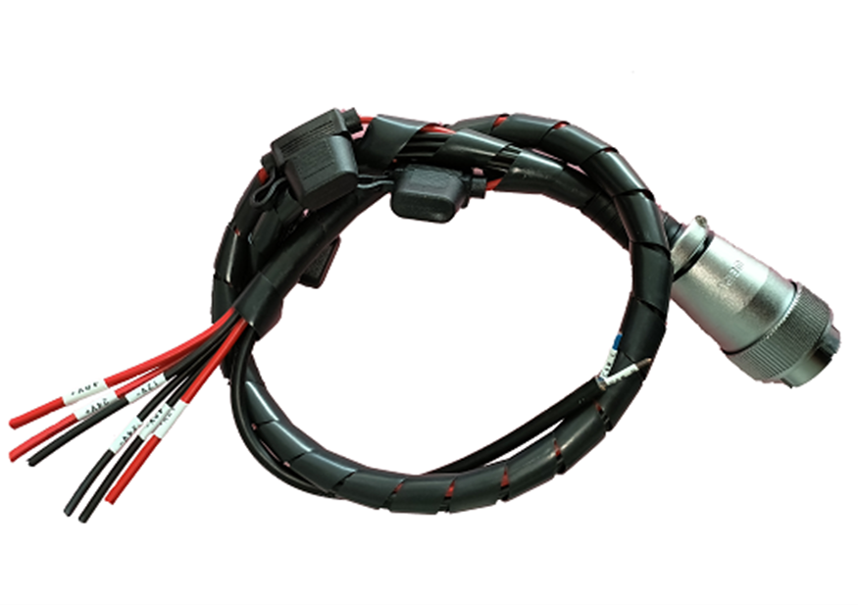

Figure 4-1 Schematic Diagram of CAN Wire Position

Red is CAN_H; Black is CAN_L

### **4.3.3.** Instructions of use of common VCU protocol

**1. Attentions during test:**

1.1 During transmission, it shall be noted that, AliveCounter requires for continuous change and cycled transmission.

1.2 During transmission of AliveCounter, it shall be specially noted that, AliveCounter occupies four bits from No. 52 to No. 55.

1.3 BYTE[7] parity bit is the first 7 Byte XOR gates: Checksum = Byte0 XOR Byte1 XOR Byte2 XOR Byte3 XOR Byte4 XOR Byte5 XOR Byte6

1.4 The following routine is a simple control command when USB CAN is used. Please control the vehicle in accordance with the communication protocol.

1.5 During the test, the remote controller is switched to automatic driving mode or turned off.

1.6 As the vehicle movement and other conditions may be tested during test by connecting to computer via CAN analyzer, please set up the vehicle during test, and after the vehicle is stably tested, put the vehicle down.

1.7 During the landing test, as the remote controller has the highest priority, it is best to turn on the remote controller for testing, facilitating to switch to the remote control mode at any time during the test.

**2. Instructions of vehicle control command ctrl_cmd**

For vehicle body control command, it is required to transmit corresponding commands, heartbeat signals and parity bits.

**(1) Targeted gear request ctrl_cmd_gear**

The command of ctrl_cmd_gear is targeted gear signal, with a physical value range of 01-04. In default, 01 is Gear P for braking; 03 is Gear N, neutral gear; 02 is Gear R, reverse gear; 04 is Gear D, drive gear; And 01 is Gear P, parking gear.

For example: When target gear requests for drive gear, -04 0x04

|  |  |  |  |  |  |  |  |  |
| --- | --- | --- | --- | --- | --- | --- | --- | --- |
| ID | D[0] | D[1] | D[2] | D[3] | D[4] | D[5] | D[6] | D[7] |
| 0x18C4D2D0 | 0x04 | 0x00 | 0x00 | 0x00 | 0x00 | 0x00 | 0x10 | 0x14 |
| 0x18C4D2D0 | 0x04 | 0x00 | 0x00 | 0x00 | 0x00 | 0x00 | 0x20 | 0x24 |
| 0x18C4D2D0 | 0x04 | 0x00 | 0x00 | 0x00 | 0x00 | 0x00 | 0x30 | 0x34 |

Note: The above three frames of signals are circulated at an interval of 10ms, and the gear can be controlled to be switched to the D gear.

Back:

|  |  |  |  |  |  |  |  |  |
| --- | --- | --- | --- | --- | --- | --- | --- | --- |
| ID | D[0] | D[1] | D[2] | D[3] | D[4] | D[5] | D[6] | D[7] |
| 0x18C4D2EF | 0x04 | 0x00 | 0x00 | 0x00 | 0x00 | 0x00 | 0x00 | 0x04 |

Note: Checkout and cyclic change of Alivecounter

**(2) Target vehicle speed request ctrl_cmd_velocity**

The command of ctrl_cmd_velocity is the target value of vehicle speed, and the physical value range of CAN communication is 0-65.535m/s (13 speed ratio, and the maximum vehicle speed of the vehicle with a wheel diameter of 420mm is 5m/s). The target vehicle speed is determined by vehicle speed precision (0.001m/s/bit). Target vehicle speed driving vehicle = 0.001* bus signal Forward and backward movement of vehicle shall be conducted in accordance with the gears.

Vehicle speed feedback is divided into three methods, they are:

1) Current vehicle speed feedback: Vehicle feedback is always positive.

2) Left and right wheel speed and vehicle speed feedback: It is the current vehicle speed corresponding to left and right wheels, during forward movement, the vehicle speed is positive, and when the backward movement is negative.

3) Left and right wheel pulse count feedback: Forward movement is the accumulation of pulse count, and backward movement is the accumulative decrease of pulse count.

For example: When the given forward movement vehicle speed is 5m/s, the bus signal is 5000 0x1388

|  |  |  |  |  |  |  |  |  |
| --- | --- | --- | --- | --- | --- | --- | --- | --- |
| ID | D[0] | D[1] | D[2] | D[3] | D[4] | D[5] | D[6] | D[7] |
| 0x18C4D2D0 | 0x84 | 0x38 | 0x01 | 0x00 | 0x00 | 0x00 | 0x00 | 0xBD |
| 0x18C4D2D0 | 0x84 | 0x38 | 0x01 | 0x00 | 0x00 | 0x00 | 0x10 | 0xAD |
| 0x18C4D2D0 | 0x84 | 0x38 | 0x01 | 0x00 | 0x00 | 0x00 | 0x20 | 0x9D |

Note: The above three frames of signals are circulated at an interval of 10ms, so that the vehicle can be controlled to move forward at a speed of 5m/s speed.

Back:

|  |  |  |  |  |  |  |  |  |
| --- | --- | --- | --- | --- | --- | --- | --- | --- |
| ID | D[0] | D[1] | D[2] | D[3] | D[4] | D[5] | D[6] | D[7] |
| 0x18C4D2EF | 0x84 | 0x38 | 0x01 | 0x00 | 0x00 | 0x00 | 0x00 | 0xBD |

Note: Cyclic change of checkout Alivecounter, the feedback may not be absolute 5m/s due to the automatic adjustment of the running vehicle speed.

The IDs of the left wheel speed and the left wheel pulse feedback are: 0x18C4D7EF

The IDs of the right wheel speed and the right wheel pulse feedback are: 0x18C4D8EF

**(3) Target steering angle ctrl_cmd_steering**

The command of ctrl_cmd_steering is the target steering angle request. The physical range of CAN communication is (-40.96)° to (40.95)°, the soft limit angle inside the vehicle is (-25)° to (+25)°. The left steering is positive and the right steering is negative. Target steering angle is determined by precision 0.01 °/bit. Target steering angle = bus signal *0.01

For example: Given angle - 25° target steering angle, the bus signal = -2500 0XF63C

|  |  |  |  |  |  |  |  |  |
| --- | --- | --- | --- | --- | --- | --- | --- | --- |
| ID | D[0] | D[1] | D[2] | D[3] | D[4] | D[5] | D[6] | D[7] |
| 0x18C4D2D0 | 0x00 | 0x00 | 0XC0 | 0x63 | 0x0F | 0x00 | 0x00 | 0xAC |
| 0x18C4D2D0 | 0x00 | 0x00 | 0XC0 | 0x63 | 0x0F | 0x00 | 0x10 | 0xBC |
| 0x18C4D2D0 | 0x00 | 0x00 | 0XC0 | 0x63 | 0x0F | 0x00 | 0x20 | 0x8C |

Note: The above three frames of signals are circulated at an interval of 10ms, the steering angle request can be -25°

Back:

|  |  |  |  |  |  |  |  |  |
| --- | --- | --- | --- | --- | --- | --- | --- | --- |
| ID | D[0] | D[1] | D[2] | D[3] | D[4] | D[5] | D[6] | D[7] |
| 0x18C4D2EF | 0x00 | 0x00 | 0XC0 | 0x63 | 0x0F | 0x00 | 0x00 | 0xAC |

Note: Checkout and cyclic change of Alivecounter.

**(4) Brake request ctrl_cmd_Brake**

Ctrl_cmd_Brake is vehicle braking openness request, and the physical value range of CAN communication is 0-100%; 0 is to release the brake, 100% is the maximum brake openness request; The feedback status is from 0 to 100%, where 0 is fully released and 100% is the maximum brake openness request.

For example: When braking openness request is 100% 0x64

|  |  |  |  |  |  |  |  |  |
| --- | --- | --- | --- | --- | --- | --- | --- | --- |
| ID | D[0] | D[1] | D[2] | D[3] | D[4] | D[5] | D[6] | D[7] |
| 0x18C4D2D0 | 0x00 | 0x00 | 0X00 | 0x00 | 0x40 | 0x06 | 0x00 | 0x46 |
| 0x18C4D2D0 | 0x00 | 0x00 | 0X00 | 0x00 | 0x40 | 0x06 | 0x10 | 0x56 |
| 0x18C4D2D0 | 0x00 | 0x00 | 0X00 | 0x00 | 0x40 | 0x06 | 0x20 | 0x66 |

Note: The above three frames of signals are circulated at an interval of 10ms, braking can be request.

Back: When the braking openness is 100%:

|  |  |  |  |  |  |  |  |  |
| --- | --- | --- | --- | --- | --- | --- | --- | --- |
| ID | D[0] | D[1] | D[2] | D[3] | D[4] | D[5] | D[6] | D[7] |
| 0x18C4D2EF | 0x00 | 0x00 | 0X00 | 0x00 | 0x40 | 0x06 | 0x00 | 0x46 |

Note: Checkout and cyclic change of Alivecounter.

**3. Instructions of auxiliary control commands**

Taking the enabling of the position lamp as an example, the control of other accessories is the same as the enabling control of the position lamp. IO port enabling control needs to send the enabling flag bit, heartbeat signal and parity bit at the same time. (If IO control is not enabled, all lighting controls will be conducted by VCU)

For example: io_cmd_clearance_lamp position lamp enabling control 0x01

|  |  |  |  |  |  |  |  |  |
| --- | --- | --- | --- | --- | --- | --- | --- | --- |
| ID | D[0] | D[1] | D[2] | D[3] | D[4] | D[5] | D[6] | D[7] |
| 0x18C4D7D0 | 0x01 | 0x20 | 0X00 | 0x00 | 0x00 | 0x00 | 0x00 | 0x21 |
| 0x18C4D7D0 | 0x01 | 0x20 | 0X00 | 0x00 | 0x00 | 0x00 | 0x10 | 0x31 |
| 0x18C4D7D0 | 0x01 | 0x20 | 0X00 | 0x00 | 0x00 | 0x00 | 0x20 | 0x01 |

Note: The above three frames of signals are circulated at an interval of 50ms, high beam lighting can be requested remotely.

Back:

|  |  |  |  |  |  |  |  |  |
| --- | --- | --- | --- | --- | --- | --- | --- | --- |
| ID | D[0] | D[1] | D[2] | D[3] | D[4] | D[5] | D[6] | D[7] |
| 0x18C4DAEF | 0x01 | 0x20 | 0X00 | 0x00 | 0x00 | 0x00 | 0x00 | 0x21 |

Note: Checkout and cyclic change of Alivecounter.

Auxiliary enabling control supports position lamp control and left and right steering lamp control; Horn control can be conducted when the IO port enable signal is set to 1 or 0; The brake lamp is not controlled by CAN signal, but completely controlled by VCU, feeding back that whether the signal is enabled or not.

# 5. Attention

This section contains some matters to be noted during use, storage and development of FR-09 Pro.

## 5.1. Attentions for battery

**▲** The battery of FR-09 Pro products may not be fully charged when they are delivered. The specific situations CAN be read through FR-09 Pro remote controller vehicle chassis voltage display or CAN bus communication interface. As for charging time, when the green indicator is on, indicating that the product has been fully charged;

**▲** DO NOT charge the battery after it is exhausted, and please charge in time when the battery voltage is too low;

**▲** The working temperature of the battery under discharging is -20°C~60°C, the battery can work normally within the specified temperature range, and the capacity loss is within the error range:

**▲** Excessive discharge of the battery is prohibited during use to avoid damage to the battery;

**▲** Avoid excessive impact on the battery; the impact beyond the specification may damage the battery, which may lead to battery leakage, heat, smoke, fire or explosion;

**▲** In case of obvious battery abnormalities, please stop using the battery immediately!

## 5.2. Attentions for charging

**▲** Charging can only be conducted by the charger matching with the battery. DO NOT use the non-original battery, power supply or charger;

**▲** Charging can only be conducted under 10°C~45°C. Charging out of this temperature range will lead to battery leakage, heating or serious damage, which may lead to deterioration of battery performance and life;

**▲** During charging, if the charger or battery is abnormal or damaged, please remove the charger input line and output line immediately;

**▲** If charging cannot be completed within the specified time, please stop charging immediately. Or, the battery may heat, have smoke or get on fire (or explode);

**▲** It is not allowed charge the battery of the vehicle body in thunderstorm weather;

**▲** It not allowed to charge the battery of the vehicle body in the place which is wet or with rain;

**▲** It is not allowed to charge the battery of the vehicle body with high temperature, such as heat source or direct sunlight, etc.;

**▲** Charging shall be conducted in the place which is ventilated and without dust;

**▲** During charging, it is not allowed to block the air inlet and outlet of the charger, there shall be a space of 10cm at least;

## 5.3. Attentions for usage environment

**▲** The working temperature of FR-09 Pro is -20℃~60℃, DO NOT use in the environment with the temperature of lower than -20℃ or higher than 60℃;

**▲** The best storage temperature for FR-09 Pro is 0℃~25℃;

**▲** DO NOT store or user in the environment with corrosive, inflammable and explosive gas;

**▲** During use and storage, please keep away from heat resources and fire resources;

**▲** Excepting for special edition (with customized IP protection level), the water-proof function of FR-09 Pro is limited. DO NOT use FR-09 Pro in the environment with deep ponding;

## 5.4. Attentions for remote operation

**▲** When debugging with the remote controller, please ensure that the remote controller is turned on and that the vehicle can receive the control instructions of the remote controller;

**▲** Make sure that all dip switch are placed at the top before starting the machine; The emergency stop switch is released; The throttle remote lever returns to zero, that is, the chassis speed is 0;

**▲** Please give priority to the low-speed gear for remote control, and then conduct the medium-speed or high-speed control test after you are familiar with the vehicle.

## 5.5. Attentions for external electrical extension

**▲** The top power supply current shall be the battery voltage and current strictly selected. Over-current is not allowed;

**▲** When the system detects that the battery voltage is lower than the safe voltage, protection procedure will be started automatically. If the external extension equipment involves storage of important data, and there is not automatic storage function for powering off, please charge timely.

## 5.6. Other attentions

**▲** During handling or setting, DO NOT fall or invert;

**▲** In case of no professionals, DO NOT disassemble without permission;

**▲** If the remote controller end will not be used for a long time, the battery shall be removed;

**▲** The tires shall be replaced timely in accordance with the wearing conditions of the patterns on the wheel tread.

# 6. Common Q&A

**Q: FR-09 Pro starts normally, however, the vehicle body does not move under the control of the remote controller?**

**A:** Firstly, confirm that whether the emergency stop switch at the tail has been released; And then, check that whether the SWA shift lever is in remote control mode, then check whether the VRB knob is controlled to unlock. Finally, check whether the SWB shift lever is the same as the control command.

**Q: FR-09 Pro What should I do that the battery of the remote controller is low, and the vehicle body stops running?**

**A:** Please replace the battery of the remote control immediately, after that, normal communication will recover soon.

**Q: Can the chassis enclosure be removed due to the modification of the vehicle body enclosure?**

**A:** This chassis is not used to bear load, and the body does not bear the internal parts. The removal of the enclosure will not greatly impact the internal parts, so it is not recommended to remove it. If necessary, please make professionals to remove, and our company undertakes no responsibilities for the losses caused by unauthorized removal.

**Q:** **Both of charger led1 and led2 are off**

**A:** Please firstly check that whether the connection of the charger input interface is correct and firm; And then, check that whether there is AC input.

Whether the battery has not been used for a long time, and whether the battery over-discharges or is damaged;

Re-plug the plugger of input and output line with a time interval of larger than 10s to judge that whether the charger is being protected.

**Q: How to turn off the remote controller when the receiver of the remote controller is not powered off?**

**A:** Please remove the remote control electromagnetic and then reinstall it, and then you can turn off the remote control without power off the remote control receiver.

# 7. Specifications

Tel.: 0755-28468956

Fax: 0755-28468956

Web: www.yuhesen.com Email: [sales01@yuhesen.com](mailto:sales01@yuhesen.com)

Address: Floor 5, Building 1, Chuangwei Qunxin Industrial Park, No. 1, Baolong 6th Road, Longgang District, Shenzhen City

**Shenzhen Yuhesen Technology Co., Ltd.**